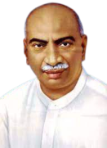
Three-Day International E-Conference
On
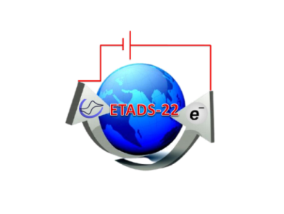
“Electrochemical Techniques and their Applications in the Development of Sensors” (ETADS-22)

Passport Size Photo

(Title……………………. )

Mr.xxxxx¹ , Mr.xxxxx² and Dr. yyyyyy *¹
¹Department of……
²Department of……

ABSTRACT (250 words)
(Times New Roman; 1.5 line space; Font 12)

Keywords: 6

Presenting Author E-mail Id: xxxxx@gmail.com
Corresponding Author E-mail Id:xxxxxx@gmail.com

